Ruby on Rails 4 Essential Training

Using exercises files:

1. Copy the folder from the exercise directory to the “Sites” directory in the app root folder.

I.E. copying “Chapter 06/06_10/simple_cms” to “App root”/Site/simple_cms

1. $ cd “App root”/ Sites/simple_cms/
2. Rake otl:import

It runs an import script

Ruby: a Object oriented language

Rails: a web application framework written in Ruby

Framework: a set of code libraries and data structures that provide functionality

Ruby Principles:

1. DRY Code: Don’t Repeat Yourself.
2. Concise, consistent code that is easy to maintain

MVC Architecture used by Ruby

Model, View, and Controller

1. Model: Data objects design
2. View: Presentation layer (HTML, CSS, etc.)
3. Controller: Processes response to user events (links, click, etc.)

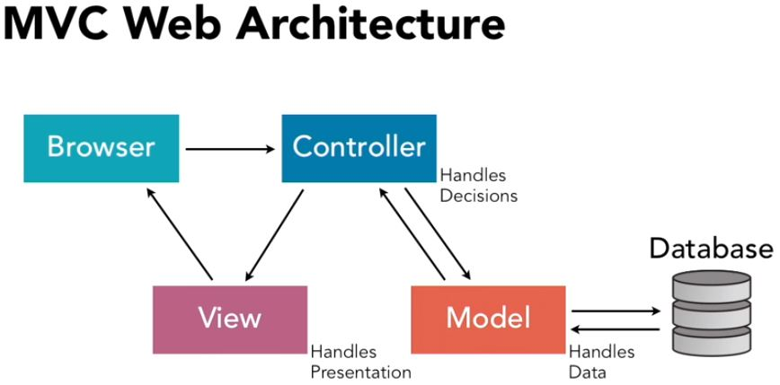

Passenger: it is a ruby module that allow rails to talk to apache

Bundler: it is a ruby gem that load all gems for the application.

AppRoot/Gemfile

//* it contains what gems will be loaded for the application

//* edit if you want to change the version of a gem that loads by bundler

//* it can be edit to disable some gems from the application (they don’t load)

//* after editon Gemfile, run bundler install

AppRoot/Gemfile.lock

//* it is the manifest (log) of bundler. It storage all gems version loaded

//* never edit this file

$ bundle install

//* it rebuilt the AppRoot/Gemfile, updating all gems with correct versions

//* it is useful if the application does not start or if mysql, etc was upgraded

$ bundler exec rake:migrate

//* run a command in the application

//* it runs the command in the context/environment of the application.

Create an Application:

$ cd /home/sysadmin

$ rails new simple_cms -d mysql

//* creates a new app that used MySQL

The AppRoot is /home/sysadmin/simple_cms/

Accessing the Application/Project

Start web server

$ rails server

$ rails s

//* start the web server

//* localhost:3000

Error: Mysql2::Error::ConnectionError (Access denied for user 'root'@'localhost' (using password: NO)):

$ nano /home/sysadmin/simple_cms/config/database.yml

Password: <Password>

Error: simple_cms database does not exist

Development

Database: #simple_cms

$ rails server

http://localhost:3000

Rails generate: The rails generate command uses templates to create a whole lot of things. Running rails generate by itself gives a list of available generators.

You can install more generators through generator gems, portions of plugins.

$ rail generate

//* show a list of available generators that can be installed

Rails generate controller: stubs out a new controller and its views as arguments to this command.

$ rails generate controller demo index

//* creates a controller named demo, and one view named index

$ nano AppRoot/app/views/demo/index.html.erb

<p> Hello world! </p>

$ rails server

http://localhost:3000/demo/index

List all views:

Nano AppRoot/config/routes.rb